ACPWM Control System for Induction Motor using AVR Microcontroller

ACPWM control for induction motor is a system, that enables the single-phase AC motor to run at different speeds. This project aims at controlling the AC power by using the concept of firing angle control of thyristors. This project uses a new speed control technique for the single-phase AC induction motor. It presents a low-cost design with high-efficiency drive capable of supplying a single-phase AC induction motor with a PWM modulated sinusoidal voltage. The circuit operation is controlled by an AVR family microcontroller. The circuit is capable of supplying a single-phase AC induction motor (or general a.c. inductive/resistive load) with varying AC voltage. The same as in triac control, the voltage applied to the load can be varied from zero to maximum value. On the other side, it uses a pulse width modulation technique (PWM circuit), and when compared with the phase angle control used for triacs, produces much lower high order harmonics. It directly modulates the mains a.c. voltage. Compared with costly converter, it requires a lower number of active and passive power components. By the means of range, the speed of induction motor is been increased with the help of button. AC voltage is provided to the load. Once it reaches to the maximum voltage which is 230 volts, it starts decreasing. It helps to control the speed of induction motor.

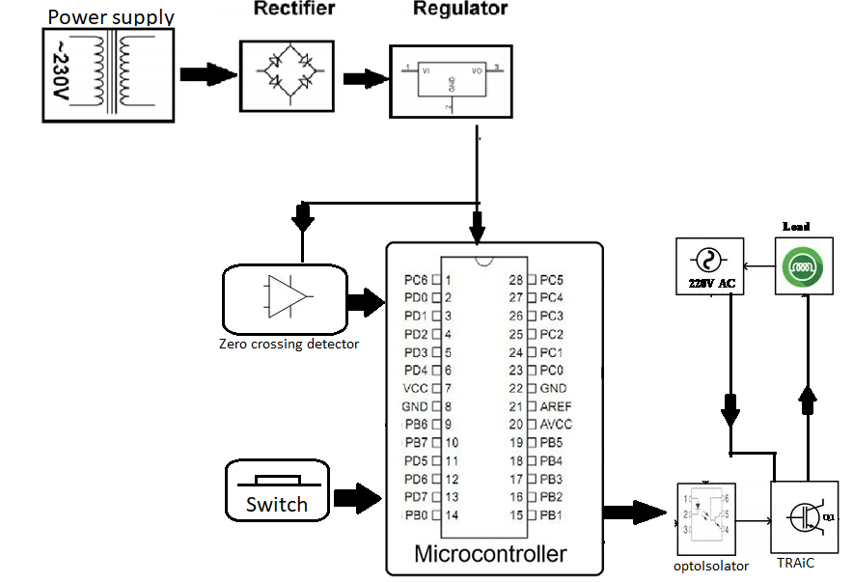

Hardware Specifications
- Power supply
- Atmega328P
- Opamp
- Opto-isolator
- TRIAC
- Regulator
- Push button
- Resistor
- Capacitor
- Led
Software Specifications

- Arduino Compiler
- Programming Language: C

